 

Web Design and Development

4COSC011W

Report

Author: Dojitha Guruge

Student ID: w1867597(20210480)

Group Number: H6

Student Role: Student 1

Link(s) to WebSite

URL: file:/w1867597-20210480/Packages/Buy_Product.html

1. Introduction 3

1.1 Topic of the website 3

1.2 Group members 3

2. Technical Discussion 4

2.1 Presentation Page 4

2.2 Buy Products 4

2.2.1 Interface 4

2.2.2 Functionality 7

3. Webpage Validation Statement 9

4. Janet 9

References 10

Appendices 10

Appendix A: Code 10

Appendix B: Screenshots 22

Appendix C: Screenshots - Webpage Validation Evidence 25

Appendix D: Individual Statement 28

# Introduction

* 1. Topic of the website
* Tourism
  1. Group members

Student 1 – Dojitha Guruge (w1867597-20210480)

* Presentation Page
* Buy Products

Student 2 – Chamindu Wanigasinghe (w1867158-20210445)

* Main Page
* Query Form

Student 3 – Janidu Rathnayaka (w1867160-20210450)

* Quiz
* Student Details

Student 4 – Manugi Bandara (w)

* Diagram SVG
* Thumbnail Images

| **Group Coursework Meetings** | | |
| --- | --- | --- |
| **1** | **Date & Time** | **10 March 2022 (face-to-face) 3hrs** |
| **Objective:** | **To assign roles to each member and choose the topic** |
| **Attended:** | **All attended** |
| **Your Contribution:** | **Choose Student 01** |
| **2** | **Date & Time:** | **13 March 2022 (remote) 2hrs** |
| **Objective:** | **Create the structure of the main page** |
| **Attended:** | **All attended** |
| **Your Contribution:** | **Add introduction to home page** |
| **3** | **Date & Time:** | **17 March 2022 (remote) 3hrs** |
| **Objective:** | **Create the main Page** |
| **Attended:** | **All attended** |
| **Your Contribution:** | **Create presentation page** |
| **4** | **Date & Time:** | **20 March 2022 (remote) 3hrs** |
| **Objective:** | **Create the footer** |
| **Attended:** | **All attended** |
| **Your Contribution:** | **Helped to student 02 to create footer CSS file** |
| **5** | **Date & Time:** | **22 March 2022 (remote) 4hrs** |
| **Objective:** | **Finalize the main Page** |
| **Attended:** | **All attended** |
| **Your Contribution:** | **Created the developer page basic html code** |
| **6** | **Date & Time:** | **25 March 2022 (remote) 3hrs** |
| **Objective:** | **Choose a logo and create social media accounts** |
| **Attended:** | **All attended** |
| **Your Contribution:** | **Created Instagram account** |
| **7** | **Date & Time:** | **27 March 2022 (remote) 5hrs** |
| **Objective:** | **Create the Additional Content Page** |
| **Attended:** | **All attended** |
| **Your Contribution:** | **Typed introductions** |
| **8** | **Date & Time:** | **28 March 2022 (remote)** |
| **Objective:** | **Finalized the Web Site** |
| **Attended:** | **All attended** |
| **Your Contribution:** | **Checked all pages** |

# Technical Discussion

The four of us decided to create travel guid web site as Tourism was the chosen topic. We also decided to go with the light theme and what’s why we chased white and that.

The task allocated to Student 01 are the presentation page and Buy products page.

2.1 Presentation Page

The title of the Presentation page is "Team Members" and below that there is a list of the member's name, IIT IDs and UOW IDs are also displayed. Not only that our logo is also displayed. The page is set to redirect to the main page of the website after 5 seconds and it is done like this.

2.2 Buy Products

2.2.1 Interface



The very top of the page have the navigation bar with the our logo and consist some useful links with a hover effected and an active effected. So the logo is on the top left corner while the links belong to the top right corner. In the right side of the page a scroll bar is there for the same purpose of the back to top button.

Bellow the navigation bar, the page consists all the tour packages with their package information and a button called "Add to Cart" to get the package to user’s cart. 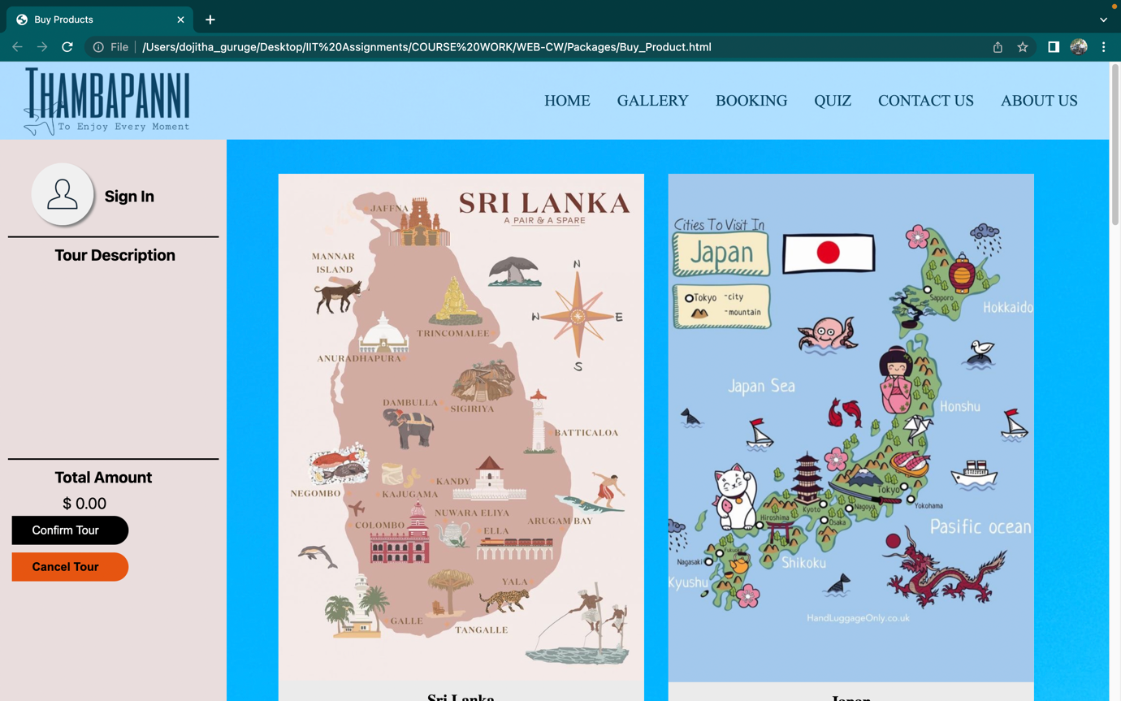

Bellow this display, there is the package information and “Add to Cart” button which is mentioned in the upper part.

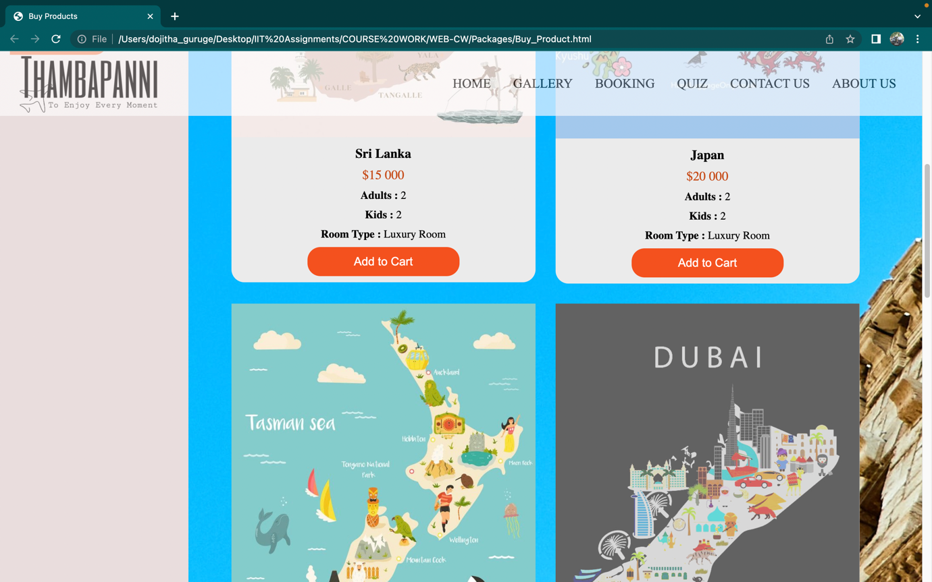

After clicking that “Add to Cart” button you must enter the number of days you wish to go on your tour.

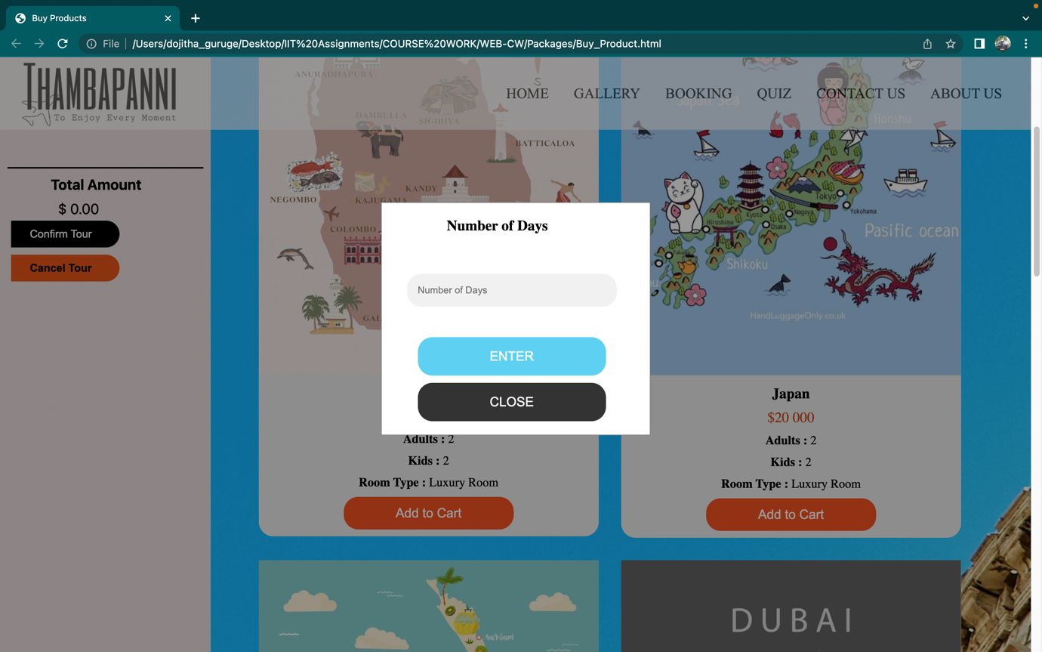

After entering the number of days, your order summery will be shown in the “Item Description” area. It will also show your total amount in “Total Amount” fiel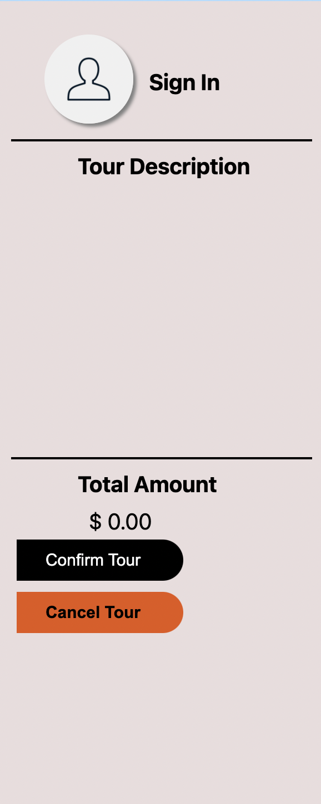d.

Then if you want to confirm your tour, you must click on the confirm button below.

After you are clicking on “Confirm Tour” button, if you are not sign-up to our web site then the sign-up form will pop up for you as follows.

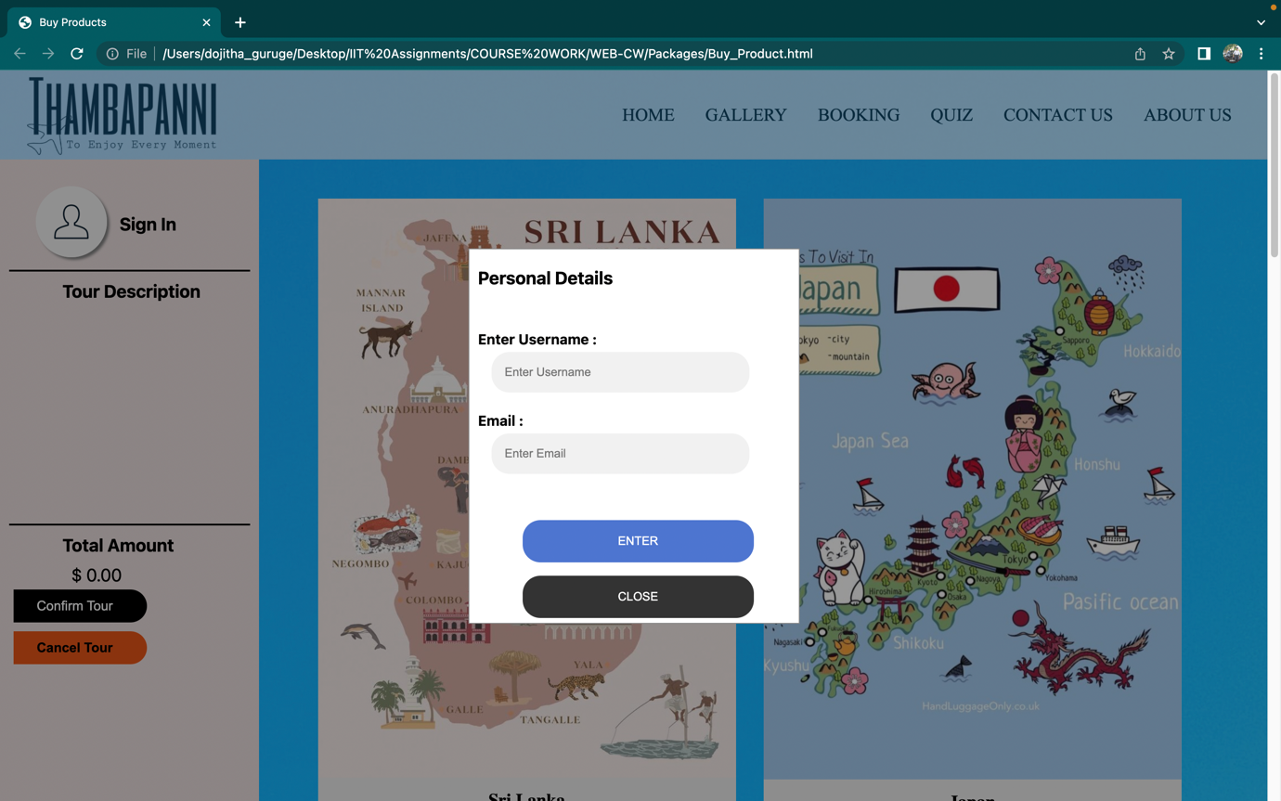

Footer is their with three major links which are known as “Contact Us”, “Development Team” and “SITE MAP”. “Development Team” is linked to the page which is included with all four developer’s images and their personal details. Likewise “Contact Us” is linked to the Query form and “SITE MAP” is Linked to the sitemap page respectively. Also there is a link to the editor’s details in the center of the bottom called as “Page Editor: Dojitha Guruge”.



2.2.2 Functionality

When the user choose tour and then the user click on “Add to Cart” button and user must input number of days to wish to tour above country. If the amount is not entered, then an error message will pop out as “Please input a Value”.

if ( isNaN(w3) || w <= 0)

alert("Please input a Value");

If the user inputs are all correct, the total will be calculated and displayed in “Total Amount” field so that the user can see the total always in that field.

All the above is done using the confirmOrder() function. The details about the all tours added to the cart by the user such as the country, tour days, and the sum of the amount of tours chosen by each individual product will also be printed in this function.

function confirmOrder() {

/*check whether the textfield is empty*/

if (username == "" || email =="")

/*Display the sog in form*/

document.getElementById("userprofile_form").style.display = "block"

else

/*pop up the final bill form and show the items and total amount*/

document.getElementById("confirm_form").style.display = "block";

document.getElementById("final_pop_up1").textContent = " Name : " + username

document.getElementById("final_pop_up2").textContent = " Email : " + email

document.getElementById("final_pop_up3").textContent = " You have select - " + tour5 + " - France Tour For " + france_tour_cost+".00 $"

document.getElementById("final_pop_up4").textContent = " You have select - " + tour4 + " - Dubai Tour For " + dubai_tour_cost+".00 $"

document.getElementById("final_pop_up5").textContent = " You have select - " + tour3 + " - New Zealand Tour For " + nz_tour_cost+".00 $"

document.getElementById("final_pop_up6").textContent = " You have select - " + tour2 + " - Japan Tour For " + japan_tour_cost+".00 $"

document.getElementById("final_pop_up7").textContent = " You have select - " + tour1 + " - Sri Lanka Tour For " + sl_tour_cost+".00 $"

document.getElementById("final_pop_up8").textContent = " YOUR TOTAL COST IS - " + total_cost + ".00 $"

This is the way the bill or the invoice is going to get printed after this whole process.

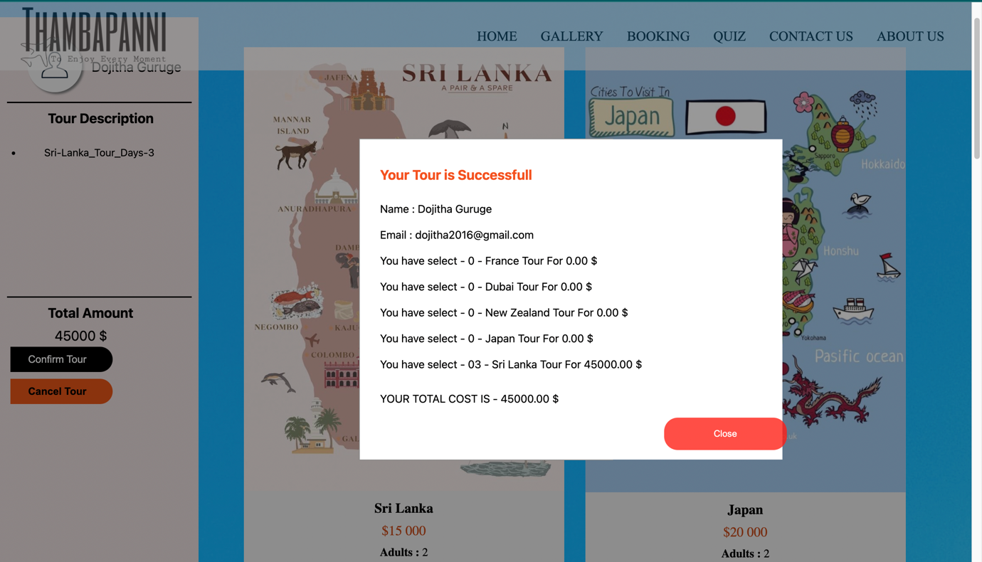

* + 1. Page Editor

So here the page includes the name of the developer and also an image, UOW ID, IIT ID, Email, Student Role and developers LinkedIn profile URL.

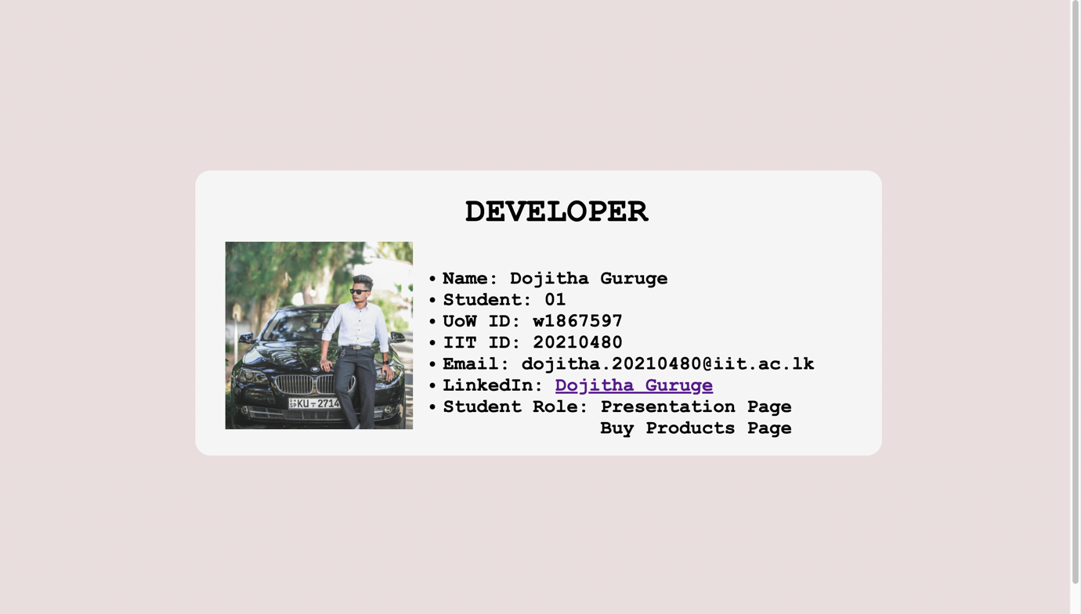

# Webpage Validation Statement

I put my buy product page html code and buy product css code to W3 code validator and it proved that there was nothing any error with that.

# Janet

Janet is a high-speed network for the UK research and education community provided by JISC, known as Joint Information Systems Committee, which is used to manage the process and the development of the UK’s national education and research network. There are also legal requirements on organizations’ use of computers and networks. Laws most likely to relevant to the development of security measures are the Data Protection Act 1998 (processing of personal data) and the Human Rights and Regulation of Investigatory Powers Acts (access to content of files and communications). Although there is currently no legal requirement on private networks to retain information about their users, keeping logs to investigate faults and misuse is strongly recommended and several different laws may allow or require these to be disclosed to third parties.

In some circumstances organizations may also be legally liable for the activities of their members. There is a general principle that an employer will normally be liable for unlawful acts by their employees. For users who are not employees (e.g., students) liability is only likely if the organization is warned of specific breaches of the law and does nothing to address them; liability for on-line activities may also be excluded if the organization’s only part in the unlawful action was to provide the network connection over which it was carried out.

# References

* W3schools – js functions - : https://www.w3schools.com/js/js_functions.asp
* Stack Overflow - Java Script Functions : <https://stackoverflow.com/search?q=java+script+functions&s=2f7913b7-99e3-42ed-8229-6e7923dbf771>
* Developer Mozilla : <https://developer.mozilla.org/en-US/docs/Web/HTML>
* Janet – regulation: <https://community.jisc.ac.uk/library/janet-services-documentation/requirements-organisation-connecting-janet>

# Appendices

## Appendix A: Code

**Presentation HTML**

<!DOCTYPE html>

<html>

<head>

<title>Presentation Page</title>

<link rel="stylesheet" type="text/css" href="Presentation_Page.css">

</head>

<body class="presentation_body">

<label class="bg_label_presentation">

<img src="Logo.jpeg" class="presentation_page_logo">

</label>

<label class="presentation_team_text"><b>Team Members</b></label>

<label class="presentation_team_members">

<ul>

<li>&nbsp Dojitha Guruge</li>

<li>&nbsp Chamindu Wanigasekara</li>

<li>&nbsp Janindu Rathnayaka</li>

<li>&nbsp Manugi Bandara</li>

</ul>

</label>

<script>

setTimeout(main_page, 5000);

function main_page()

{

location.replace("Home.html")

}

</script>

</body>

</html>

**Presentation CSS**

.presentation_body

{

background-image:url("ninearch.jpg");

background-attachment: fixed;

background-size:cover;

}

/* Add labels which include text */

.bg_label_presentation

{

position:absolute; /* Make the position of the image */

top:230px;

margin-left: 50px;

height: 80px;

width: 560px;

right:250px;

left:250px;

bottom:60px;

padding:130px; /* Add padding */

padding-left:125px;

opacity: 0.3;

background-color: azure;/* Add background Color */

opacity:0.6; /* Change the opacity */

}

.presentation_page_logo

{

position:absolute;

padding-left: 40px;

padding-top: 20px;

right:0px;

left:0px;

top:75px;

bottom:80px;

width:550px;

height:200px;

}

.presentation_team_text

{

width:300px;

height:500px;

color:#000000;

font-family:Cambria;

font-size:40px;

padding-left:550px;

top:260px;

position:absolute;

right:20px;

left:20px;

}

.presentation_team_members

{

width:600px;

height:500px;

color:black;

font-family:ISOCPEUR;

font-size:25px;

position:absolute;

top:335px;

right:70px;

left:750px;

font-weight:bold;

}

**Packages HTML**

<!DOCTYPE html>

<html lang="en">

<head>

<title>Buy Products</title>

<link rel="stylesheet" type="text/css" href="Buy_Product.css">

<link rel="stylesheet" href="header.css">

<link rel="stylesheet" href="footer.css">

</head>

<body class="body-bg" >

<!-- Navigation Bar -->

<nav>

<a href="../Home/home.html">

<img id="logo" src="Logo.jpeg" alt="logo" width="300" height="90"/>

</a>

<ul class="nav-ul">

<li><a href="../Home/home.html">Home</a></li>

<li><a href="../Stars/AboutUs.php">Gallery</a></li>

<li><a href="../Contact/php/send.php">Booking</a></li>

<li><a href="../Packages/Packages.html">Quiz</a></li>

<li><a href="https://edition.cnn.com/">Contact Us</a></li>

<li><a href="https://www.google.com/">About Us</a></li>

</ul>

</nav>

<!-- Declaring section -->

<div>

<!-- Declaring a sub section -->

<div class="section1">

<!-- Sri Lanka-->

<div class="card">

<!-- Add image , give the width -->

<img src="Srilanka.JPG" style="width:100%" alt="Sri Lanka">

<div class="h1country">Sri Lanka</div>

<p class="price">$15 000</p>

<p class="tdetail"><span><b>Adults :</b></span> 2 </p>

<p class="tdetail"><span><b>Kids :</b></span> 2 </p>

<p class="tdetail"><span><b>Room Type :</b></span> Luxury Room</p>

<!-- Add onclick events yo the button -->

<p><button onclick="openForm_1()" class="open-button" id="sri_lanka" >Add to Cart</button></p>

<!-- Pop up user to how many days you want to travel -->

<div id="SL_form" class="modal">

<div class="modal-content">

<form class="form-container">

<div class="h1country">Number of Days </div>

<!-- Add textfield -->

<input type="text" placeholder="Number of Days" id="sl_tour_days" required>

<!-- Add onclick events for the buttons -->

<button type="submit" class="btnTour" id="Sri-Lanka_Tour_Days-" onclick="Srilanka()">ENTER</button>

<button type="button" class="btnTour cancel" onclick="closeForm_1()">CLOSE</button>

</form>

</div>

</div>

</div>

<!-- Japan -->

<div class="card">

<img src="Japan.jpg" style="width:100%" alt="Japan">

<div class="h1country">Japan</div>

<p class="price">$20 000</p>

<p class="tdetail"><span><b>Adults :</b></span> 2 </p>

<p class="tdetail"><span><b>Kids :</b></span> 2 </p>

<p class="tdetail"><span><b>Room Type :</b></span> Luxury Room</p>

<p><button onclick="openForm_2()" class="open-button" id="japan">Add to Cart</button></p>

<div id="japan_form" class="modal">

<div class="modal-content">

<form class="form-container">

<div class="h1country">Number of Days </div>

<input type="text" placeholder="Number of days" id="japan_tour_days" required>

<button type="submit" class="btnTour" id="Japan_Tour_Days-" onclick="Japan()">ENTER</button>

<button type="button" class="btnTour cancel" onclick="closeForm_2()">CLOSE</button>

</form>

</div>

</div>

</div>

<!-- New Zealand -->

<div class="card">

<img src="NewZealand.JPG" style="width:100%" alt="New Zealand">

<div class="h1country">New Zealand</div>

<p class="price">$12 000</p>

<p class="tdetail"><span><b>Adults :</b></span> 2 </p>

<p class="tdetail"><span><b>Kids :</b></span> 2 </p>

<p class="tdetail"><span><b>Room Type :</b></span> Luxury Room</p>

<p><button onclick="openForm_3()" class="open-button" id="newzealand">Add to Cart</button></p>

<div id="nz_form" class="modal">

<div class="modal-content">

<form class="form-container">

<div class="h1country">Number of Days </div>

<input type="text" placeholder="Number of days" id="nz_tour_days" required>

<button type="submit" class="btnTour" id="New-Zealand_Tour_Days-" onclick="NewZealand()">ENTER</button>

<button type="button" class="btnTour cancel" onclick="closeForm_3()">CLOSE</button>

</form>

</div>

</div>

</div>

<!-- Dubai -->

<div class="card">

<img src="dubai.JPEG" style="width:100%" alt="Dubai">

<div class="h1country">Dubai</div>

<p class="price">$28 000</p>

<p class="tdetail"><span><b>Adults :</b></span> 2 </p>

<p class="tdetail"><span><b>Kids :</b></span> 2 </p>

<p class="tdetail"><span><b>Room Type :</b></span> Luxury Room</p>

<p><button onclick="openForm_4()" class="open-button" id="dubai">Add to Cart</button></p>

<div id="dubai_form" class="modal">

<div class="modal-content">

<form class="form-container">

<div class="h1country">Number of Days </div>

<input type="text" placeholder="Number of Days" id="dubai_tour_days" required>

<button type="submit" class="btnTour" id="Dubai_Tour_Days-" onclick="Dubai()">ENTER</button>

<button type="button" class="btnTour cancel" onclick="closeForm_4()">CLOSE</button>

</form>

</div>

</div>

</div>

<!-- France-->

<div class="card">

<img src="france.JPG" style="width:100%" alt="France">

<div class="h1country">France</div>

<p class="price">$30 000</p>

<p class="tdetail"><span><b>Adults :</b></span> 2 </p>

<p class="tdetail"><span><b>Kids :</b></span> 2 </p>

<p class="tdetail"><span><b>Room Type :</b></span> Luxury Room</p>

<p><button onclick="openForm_5()" class="open-button" id="france" >Add to Cart</button></p>

<div id="france_form" class="modal">

<div class="modal-content">

<form class="form-container">

<div class="h1country">Number of Days </div>

<input type="text" placeholder="Number of Days" id="france_tour_days" required>

<button type="submit" class="btnTour" id="France_Tour_Days-" onclick="France()">ENTER</button>

<button type="button" class="btnTour cancel" onclick="closeForm_5()">CLOSE</button>

</form>

</div>

</div>

</div>

</div>

<!-- End of the section -->

<!-- Add left section -->

<div class="aside1" >

<div>

<!-- Image use to obtain user informaton -->

<img src= "bsi.JPG" class="user_profile" id="user" onclick="userProfile()" alt="signin image">

<!-- Label that shows the user name -->

<label class="user_label" id="username_label"><b>Sign In</b></label>

<!-- User login form-->

<div id="userprofile_form" class="modal">

<div class="modal-content">

<form class="user-container">

<div class="h1country">Personal Details</div><br><br>

<p><b>Enter Username :</b></p>

<!-- Obtain the name -->

<input type="text" placeholder="Enter Username" id="username" required>

<p><b>Email :</b></p>

<!-- Obtain the email -->

<input type="email" placeholder="Enter Email" id="email">

<button type="submit" class="btnTour" onclick="addUser()">ENTER</button>

<button type="button" class="btnTour cancel" onclick="close_userProfile() " id="inputw1">CLOSE</button>

</form>

</div>

</div>

</div>

<hr style="border: 1px solid #000; ">

<p class="para"><b> Tour Description</b></p>

<div class="item_list" >

<form>

<ul id="list"></ul>

</form>

</div>

<hr style="border: 1px solid #000; ">

<p class="para"><b>Total Amount</b></p>

<label id="total_bill" class="tot_label">$ 0.00</label>

<div>

<button class="confirm_btn" onclick="confirmOrder()"><span>Confirm Tour </span></button>

<div id="confirm_form" class="modal">

<div class="modal-content">

<form class="confirm_form-container">

<div class="padding_final_form">

<div class="h1country" style="color:#f4511e">Your Tour is Successfull</div><br>

<label id="final_pop_up1" class="final_pop_up"></label><br><br>

<label id="final_pop_up2" class="final_pop_up"></label><br><br>

<label id="final_pop_up3" class="final_pop_up"></label><br><br>

<label id="final_pop_up4" class="final_pop_up"></label><br><br>

<label id="final_pop_up5" class="final_pop_up"></label><br><br>

<label id="final_pop_up6" class="final_pop_up"></label><br><br>

<label id="final_pop_up7" class="final_pop_up"></label><br><br>

<label id="final_pop_up8" class="final_pop_up"></label>

<button type="button" class="close_btn" onclick="closeForm_confirm()" id="inputw2">Close</button>

</div>

</form>

</div>

</div>

<button class="cancel_btn" onclick="cancelOrder()" ><span>Cancel Tour </span></button><br><br><br>

</div>

</div>

<script src="Buy_Product_Script.js"> </script>

</div>

<br><br><br><br><br><br><br><br><br><br><br><br><br><br><br><br><br><br><br><br><br><br><br><br><br><br><br><br><br><br><br><br><br><br><br><br><br><br><br><br><br><br><br><br><br><br><br><br><br><br><br><br><br><br><br><br><br><br><br><br><br><br><br><br><br><br><br><br><br><br><br><br><br><br><br><br><br><br><br><br><br><br><br><br><br><br><br><br><br><br><br><br><br><br><br><br><br><br><br><br><br><br><br><br><br><br><br><br><br><br><br><br><br><br><br><br><br><br><br><br><br><br><br><br><br><br><br><br><br><br><br><br><br><br><br><br><br><br><br><br><br><br><br><br><br><br><br><br><br><br><br><br><br><br><br><br>

<!-- footer -->

<footer>

<div class="footer">

<div class="row">

<div class="item">

<h3>About Us</h3>

<ul>

<li><a href="#">Contact Us</a></li>

<li><a href="#">Development Team</a></li>

<li><a href="#">SITE MAP</a></li>

</ul>

</div>

<div class="text">

<form action="mailto:jaanidurathnayaka@gmail.com">

<label for="newsfeed">News Feed</label><br />

<input

type="email"

name="newsfeed"

id="newsfeed"

class="newsfeed"

placeholder="Email Adress"

/>

<input type="submit" value="Subscribe" />

</form>

</div>

</div>

<div class="social">

<h3>Follow Us</h3>

<a href="" >

<img src="HF-Images/Instagram.png" alt="Instagram"/>

</a>

<a href="https://www.facebook.com/Thambapannicom-109229721731694/" target="_blank">

<img src="HF-Images/Facebook.png" alt="FaceBook"/>

</a>

<a href="https://t.co/dh7kvN8Kd" target="_blank">

<img

src="HF-Images/Twitter.png"

alt="Twitter"/>

</a>

<a href="#" target="_blank">

<img

src="HF-Images/LinkedIn.png"

alt="LinkedIn"/>

</a>

</div>

<p class="copyright">Thambapanni &copy; 2022</p>

<p class="copyright">

Page Editor:

<a href="Dojitha-PE.html" target="_blank">Dojitha Guruge</a>

</p>

</div>

</footer>

</body>

</html>

**Packages CSS**

/* Buy products web page begin here */

/* Css for items */

.card {

max-width: 470px;

max-height : 1000px;

text-align: center;

font-family: Bahnschrift;

float:left;

margin: 30px 30px 1px 1px ;

background-color : #EBEBEB;

border-radius: 20px;

}

/* Css for price */

.price {

color: #c54a15;

font-size: 20px;

padding-bottom:10px;

}

/* Edit button contain in the card */

.card button {

border: none;

outline: 0;

padding: 12px;

color: white;

background-color: #f4511e;

text-align: center;

cursor: pointer;

width: 50%;

font-size: 18px;

position:static;

border-radius: 20px;

margin-bottom: 2%;

}

/* Add hover effects for the button */

.card button:hover {

opacity: 0.8;

}

.h1country{

font-size:20px;

font-weight: bold;

color: black;

padding-bottom:10px;

padding-top:10px;

}

.body-bg{

background-image:url("bbg.jpg");

}

.tdetail {

padding-bottom:10px;

font-size:17px;

}

/* Divide page in to two , declaring the width ND POSITION */

.section1 {

float: right ;

width:75% ;

margin-top: 8%;

}

/* Add styles to the form container */

.form-container {

width: 300px;

height:300px;

padding: 10px;

background-color: white;

}

/* input fields */

.form-container [type=text]{

width: 260px;

padding: 15px;

margin: 5px 0 22px 0;

border: none;

background: #f1f1f1;

position:relative;

top:40px;

left: 20px;

border-radius: 20px;

}

/* Set a style for the submit button */

.form-container .btnTour {

background-color: #19c5f0;

color: white;

padding: 16px 20px;

border: none;

cursor: pointer;

width: 260px;

margin-bottom:10px;

opacity: 0.8;

position:relative;

left:20px;

top:60px;

border-radius: 20px;

}

/* Add a red background color to the cancel button */

.form-container .cancel {

background-color: black;

}

/* Add effects to buttons */

.form-container .btnTour:hover, .open-button:hover {

opacity: 1;

}

/* Modal Content */

.modal-content {

position: relative;

top:100px;

background-color: white;

margin: auto;

padding: 0;

border: 1px solid #888;

width: 26%;

}

/* The Modal (background) */

.modal {

display: none; /* Hidden by default */

position: fixed;

z-index: 1;

padding-top: 100px;

left: 0;

top: 0;

width: 100%;

height: 100%;

background-color: rgb(0,0,0,0.4); /* Fallback color */

}

.modal-body {

padding: 2px 16px;

}

/* Lesft side of the page */

.aside1 {

background-color: #e9dddd;

float:left;

width: 19%;

height:2736px;

padding:10px;

padding-top : 40px;

font-family : -apple-system, BlinkMacSystemFont, 'Segoe UI', Roboto, Oxygen, Ubuntu, Cantarell, 'Open Sans', 'Helvetica Neue', sans-serif;

margin-top: 7%;

}

/* Add css for the image use to log in */

.user_profile{

border-radius:50px;

display: inline-block;

border:none;

position:relative;

left:30px;

bottom:10px;

box-shadow: 3px 3px 3px grey;

outline: 0;

height:80px;

width:80px;

}

/* Edit the label shows the username */

.user_label{

position:relative;

left:40px;

bottom:40px;

font-size:20px;

}

.user_profile:hover {

opacity : 0.8;

}

.hr_line{

position:static;

top:20px;

border: 2px solid red;

}

.para{

font-size:20px;

padding:10px;

padding-left:60px ;

}

/* Edit the item list */

.item_list{

font-size:15px;

padding:20px;

max-height:200px;

height:200px;

text-align:center;

overflow:auto;

}

.tot_label{

font-size:20px;

text-align:center;

padding-left:70px;

height:30px;

}

/* Add css to the confirm button */

.confirm_btn {

display: inline-block;

border-radius: 0px 20px 20px 0px;

background-color: black;

border: none;

color: White;

text-align: center;

font-size:15px;

padding:10px;

width: 150px;

transition: all 0.5s;

cursor: pointer;

margin: 5px;

outline: 0;

-webkit-box-shadow: none;

box-shadow: none;

vertical-align:middle;

cursor: pointer;

position: relative;

transition: 0.5s;

}

/* Add animation to the confirm button */

.confirm_btn span:after {

content: '\00bb';

position: relative;

left:10px;

opacity: 0;

top: 0;

right: -20px;

transition: 0.5s;

}

.confirm_btn:hover span {

padding-right: 25px;

}

.confirm_btn:hover span:after {

opacity: 1;

right: 0;

}

.cancel_btn {

display: inline-block;

border-radius: 0px 20px 20px 0px;

background-color: rgb(230, 85, 18);

border: none;

color: black;

font-weight:bold;

text-align: center;

font-size:15px;

padding:10px;

width: 150px;

transition: all 0.5s;

cursor: pointer;

margin: 5px;

outline: 0;

-webkit-box-shadow: none;

box-shadow: none;

vertical-align:middle;

cursor: pointer;

position: relative;

transition: 0.5s;

}

.cancel_btn span:after {

content: '\00bb';

position: relative;

left:10px;

opacity: 0;

top: 0;

right: -20px;

transition: 0.5s;

}

.cancel_btn:hover span {

padding-right: 25px;

}

.cancel_btn:hover span:after {

opacity: 1;

right: 0;

}

.confirm_form-container {

width: 600px;

height:450px;

padding: 10px;

background-color: white;

}

.padding_final_form{

padding:20px;

}

.confirm_form-container .close_btn {

background-color: red;

color:white;

position:relative;

left:150px;

top:50px;

padding: 16px 20px;

border: none;

cursor: pointer;

width: 180px;

margin-bottom:10px;

opacity: 0.8;

border-radius: 20px;

}

.form-container .btnShop:hover, .open-button:hover {

opacity: 1;

}

/* Add styles to the form container */

.user-container {

width: 300px;

height:400px;

padding: 10px;

background-color: white;

}

/* Full-width input fields (for username)*/

.user-container [type=text]{

width: 260px;

padding: 15px;

margin: 5px 0 22px 0;

border: none;

border-radius: 20px;

background: #f1f1f1;

position:relative;

left:15px;

}

/* Full-width input fields (for email)*/

.user-container [type=email]{

width: 260px;

padding: 15px;

margin: 5px 0 22px 0;

border: none;

border-radius: 20px;

background: #f1f1f1;

position:relative;

left:15px;

}

/* Set a style for the submit/login button */

.user-container .btnTour {

background-color: #1d52c4;

color: white;

padding: 16px 20px;

border: none;

cursor: pointer;

width: 260px;

margin-bottom:15px;

opacity: 0.8;

position:relative;

left:50px;

bottom: -30px;

border-radius: 20px;

}

/* Add a red background color to the cancel button */

.user-container .cancel {

background-color: black;

}

/* Add some hover effects to buttons */

.user-container .btnShop:hover, .open-button:hover {

opacity: 1;

}

## Appendix B: Screenshots

**Presentation Page.html**

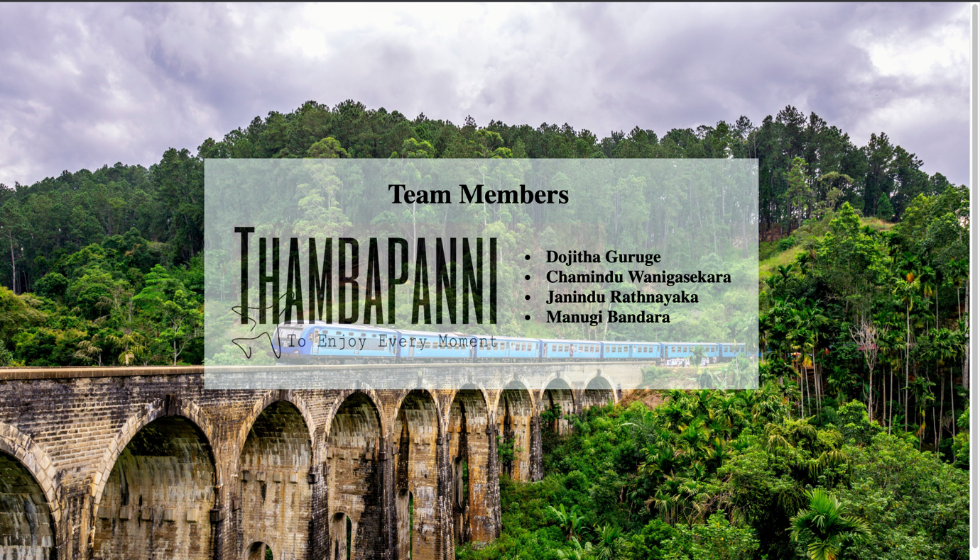

**Packages.html**

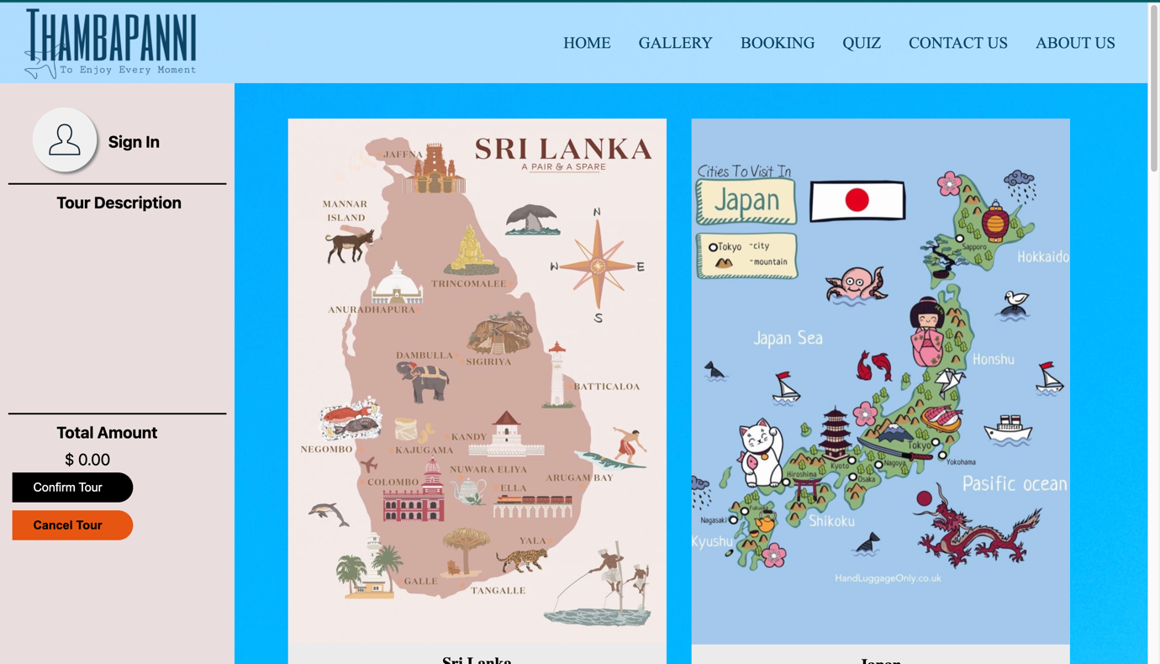

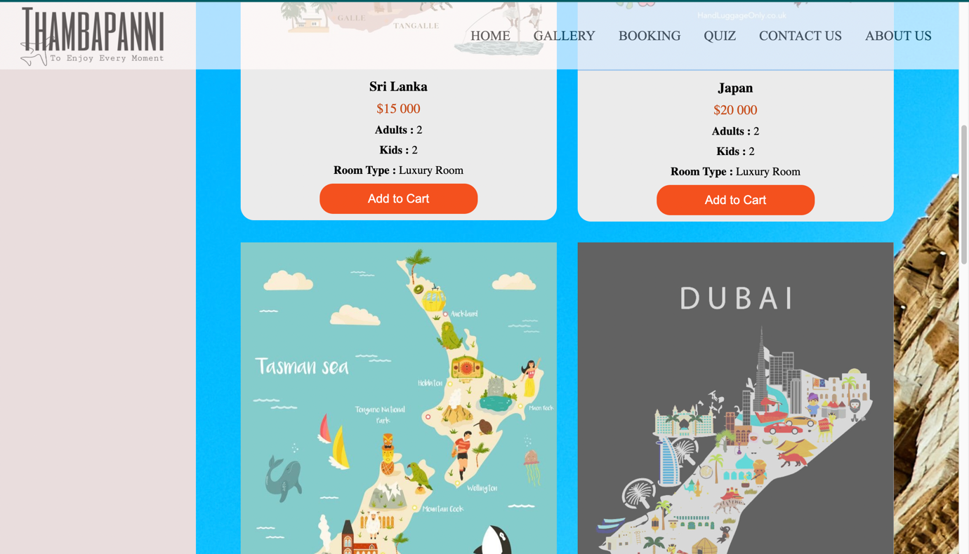

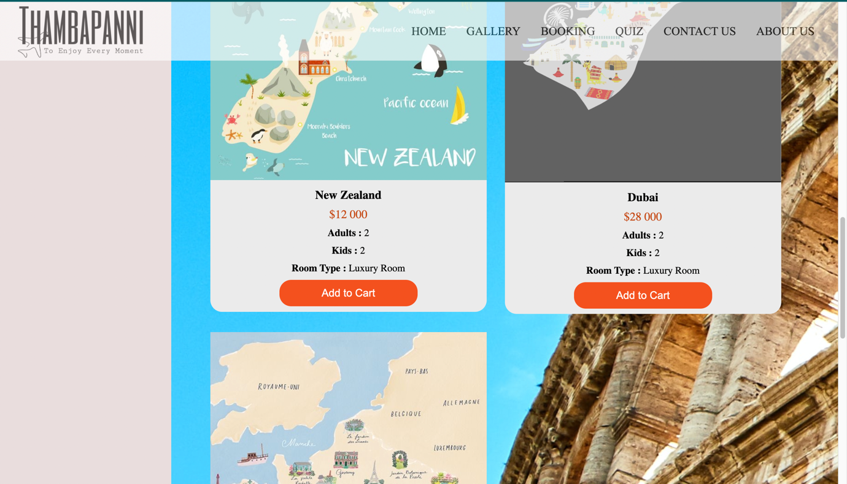

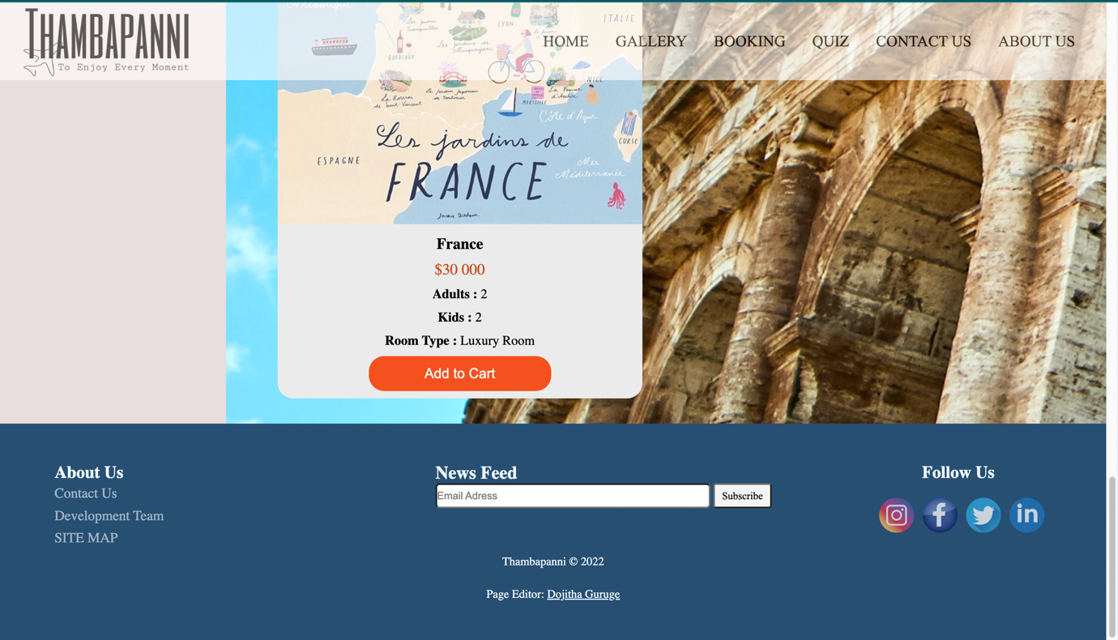

## Appendix C: Screenshots - Webpage Validation Evidence

**Packages.html**

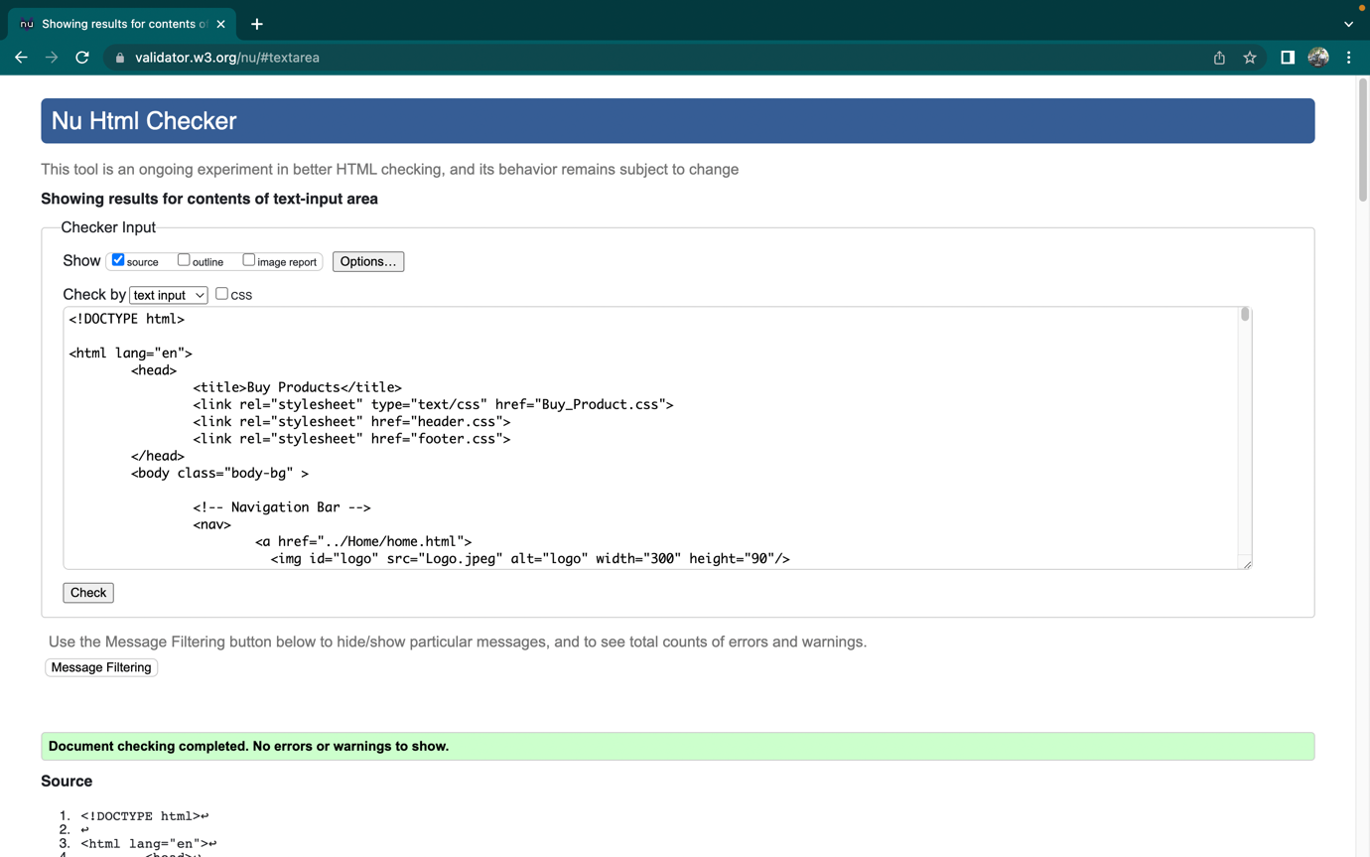

**Packages.css**

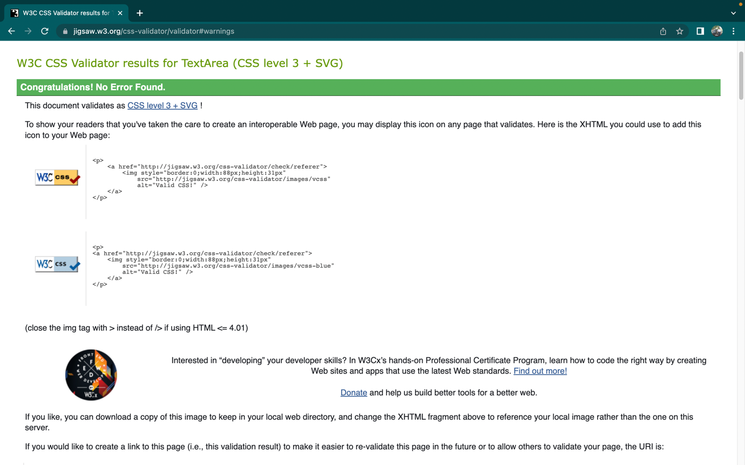

**Presentation.html**

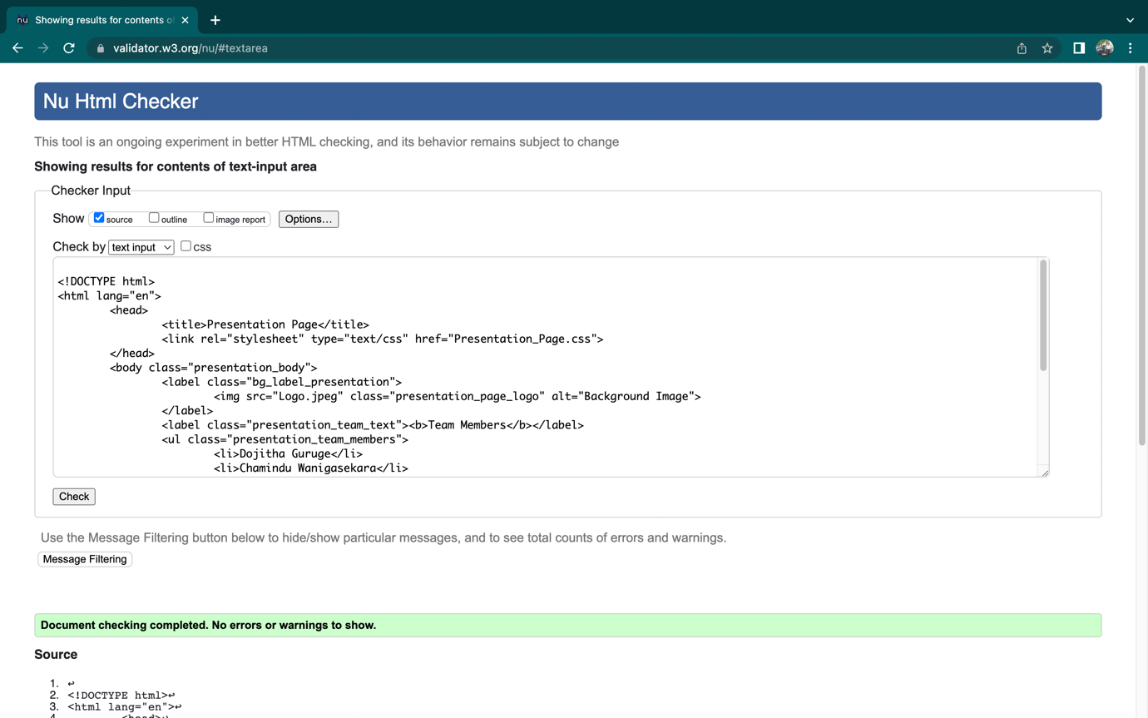

**Presentation.css**

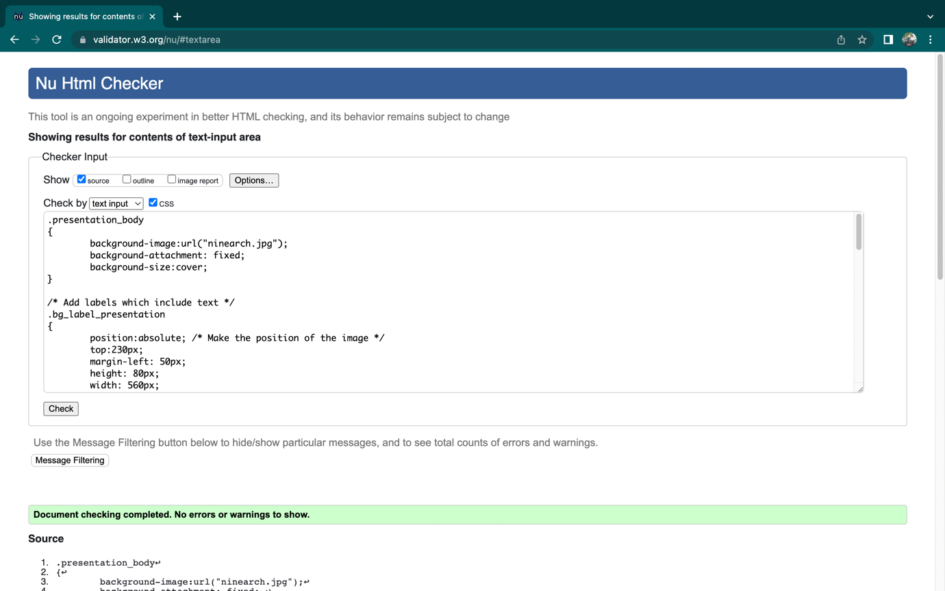

## Appendix D: Individual Statement

| Student Name: | Dojitha Guruge | Student Id: | W1867597  20210480 |
| --- | --- | --- | --- |
| State what tasks you carried out in the project. | | | |
| Presentation page.  Buy Products page.  Developer page. | | | |
| State what you enjoyed and did not enjoy about teamwork. | | | |
| What I enjoyed most about working as a team was being able to make new friends, to share our ideas and, the most important thing is that to help each other with their problems which they individually faced.  The thing I didn’t like about my team was being physically detached from my teammates due to this pandemic and it caused somewhat boring sometimes, but we overcame it. | | | |
| State what you learnt about teamwork. | | | |
| If we want to get a perfect outcome, then we all must contribute our 100%. | | | |
| State what skills you gained/learnt from undertaking the project. | | | |
| Being patience with the teammates, and how to become a good listener. | | | |
| State any strengths about yourself that emerged whilst undertaking the project. | | | |
| I gained and improved my knowledge in CSS, HTML and specially in JavaScript. | | | |
| State any weaknesses about yourself that emerged whilst undertaking the project. | | | |
| Not having much knowledge, especially in JavaScript which resulted in taking more time to finish the project than expected. | | | |
| State how you would do things better if you were to undertake the project again. | | | |
| I would try to manage my time with the other subjects and try to give my 100% next time as this time I failed in time management as it was my first time to do such a workload. | | | |
| Additional general or project specific comments: | | | |
| __ | | | |